​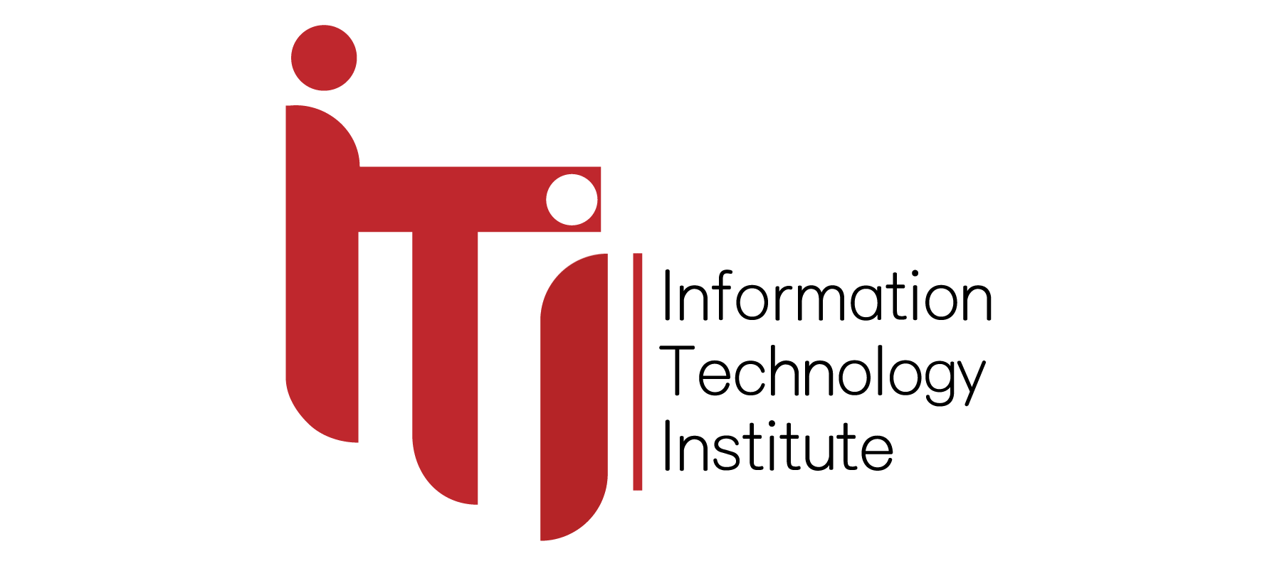

*Information Technology Institute*

*Power BI Developer Track*

**Examination System**

Supervisor:

Eng. **Rami Nagi**

**Presented by:**

Alaa Gamal Abdelhamid

Aya Mahmoud Amin

Gemiana Shawky Amanoeil

Mariam Farag Tawfik

Rahma Zakaria Hassan

## ABSTRACT

For assessing and improving qualifications proficiency we need an essential tool to tell us whether these qualifications are put in their right places or not, to this reason, we introduce an examination system used to evaluate a student’s knowledge and understanding of a particular subject or course.

The exam results can be used to identify areas that require improvement and to guide training and development efforts, and even these we are conversant with online courses as exceeded besides freelancing jobs to trace what students learned.

Moreover, the examination system is an essential component of the assessment process, which helps ensure quality education. As such, educational institutions need to design examination systems that are fair, reliable, and valid, to ensure that students receive accurate and meaningful feedback on their learning progress.

## INTRODUCTION

The pace of technological advancement is accelerating at an unprecedented rate, and it is evident that technology is expanding and improving day by day, it has become more important for us to adapt and understand our needs in this ever-evolving landscape; hence, the examination system serves as a crucial tool in accurately assessing our current knowledge, it enables them to identify strengths and weaknesses, track progress, and make data-driven decisions about training and development needs, and identifying areas for growth to keep pace with the advancements of technical skills in the data science and other courses.

It will consist of departments divided into instructors that will facilitate studying to students and take their hands towards their careers, courses cope with the technology evolution with the increasing importance of data-driven decision-making towards the ability to work with Python, OOP, SQL, Data warehouse, data mining, and other tracks including C++, C#, Java, HTML, and JavaScript as it is becoming essential for students who develop himself by studying more and more with professional instructors, and companies who develop the country by those students. It can incorporate different types of exams, such as multiple choice, true or false. these types will be faster and more useful for mental health struggles.

Because of guarantee a healthy study, we suggest getting the student’s health status and their emergency contact to guarantee the students’ health and assure that they can meet deadlines, and achieve good grades without stress and anxiety for students’ effect on any disease he has, particularly if they are struggling with technical subjects or feel overwhelmed by the workload.

By taking exams and receiving feedback on their performance, individuals can identify areas where they need to improve and focus their learning efforts accordingly. This can help them stay up-to-date with the latest technologies and best practices in the field, after the student gives his feedback, he can get his grades to decide if he should repeat the course content or if he already reached the stars from it, and now he has finished all courses so, it is his time to be certified an individual's proficiency from the intake, as certifications can serve as valuable credentials for job seekers and employers seeking to hire skilled professionals.

To demonstrate proficiency to potential employers and increase job prospects after getting their grades from the examination system can be used to certify individuals' proficiency as certifications in each online course or once completing the intake, which can serve as valuable credential certification for job seekers and employers seeking to hire skilled professionals’ system also enables individuals to benchmark their skills and knowledge against industry standards and best practices. This can be useful for identifying improvement areas and setting personal and professional development goals.

In the intake, online courses and freelancing jobs can be used in conjunction with the examination courses system to create a comprehensive learning experience. For example, individuals can take exams to evaluate their proficiency before and after completing online programs to assess their learning progress.

Dashboards can be created to visualize the exam results, allowing instructors and individuals to track their progress toward mastery of the subject matter. The dashboards can provide detailed information about the student’s enrolment process till taking the courses to finish them with the final intake certificate qualify them to work in a fitting company, also presented the data from stored procedures to SQL Server Report Server that shows exams by each exam number.

## IMPLEMENTATION LIFE CYCLE

The implementation life cycle is an iterative process needed to ensure the system meets the requirements that outline the phases a system goes through, from entity relationship diagrams to reports and interactive dashboards.

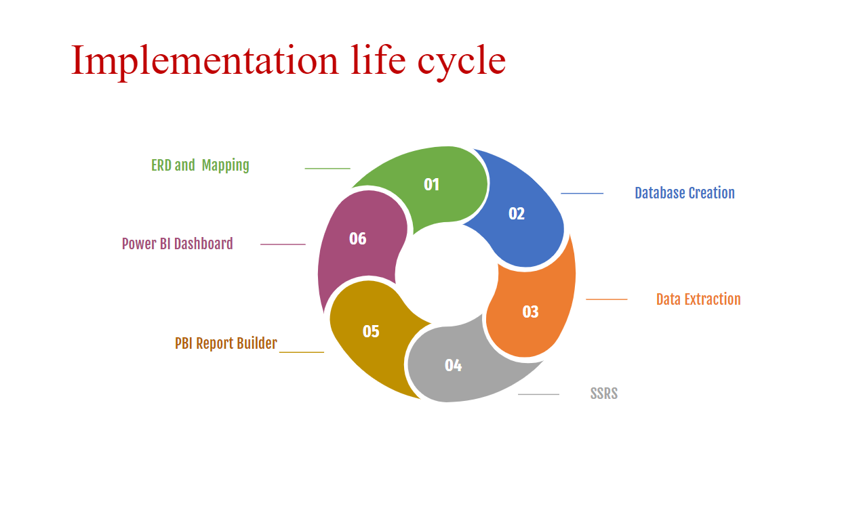

**ERD& Mapping:** In this phase, we created detailed design specifications for the entity relationship diagram, and database schema, and developed dashboard perspectives.

**Database creation:** Here, we coded the database schema, integrated the components into a working system, and tested the system to ensure it can manage exams and answers.

**Data extraction:** extracting data from a database for generating reports in Power BI Desktop, SQL Server Report Service, or Power BI Report Builder involves querying the database, saving the data as a CSV file, and importing the data into the reporting tool, or directly connecting to the database from the reporting tool and extracting the data.

**SSRS:** SQL Serverreport server to present the data from stored procedures to SQL Server Report Server to show the targeted report like different courses, topics, and exams.

**Power BI Report builder:** paginated report designed for creating a report definition that specifies what data to retrieve like Report that returns the students’ information according to Department No parameter, and Report that takes the exam number and the student ID and then returns the Questions in this exam with the student answers.

**Power BI Dashboard:** to provide valuable insights into the department, instructor, student performance, and exam results, helping instructors make informed decisions about how to improve the intake quality and support more student learning through online courses and do more practice by freelancing jobs.

DATABASE DESIGN (ERD)

Examination system ERD includes entities such as Intake, department, students, questions, feedback, exams, courses, grades, health status, and their relationships to each other.

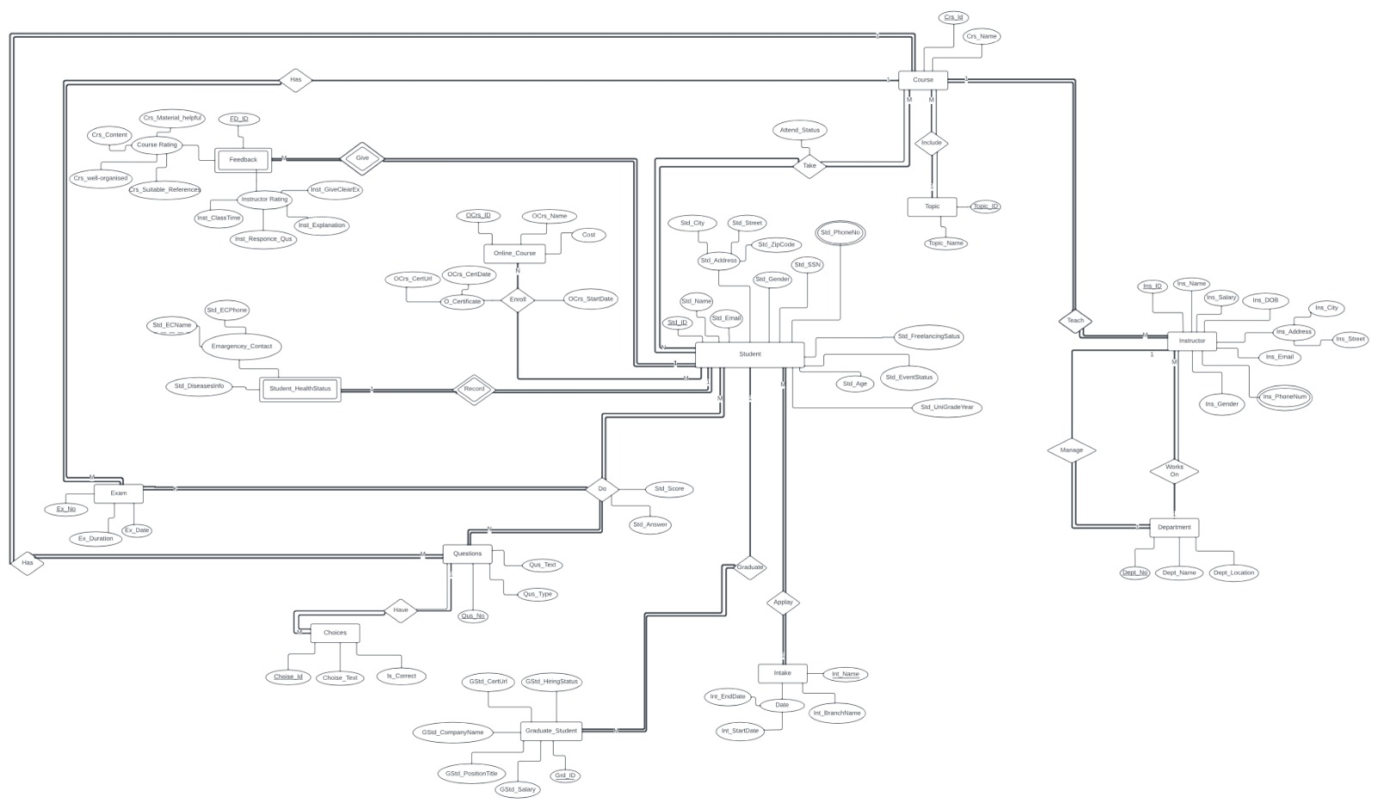

DATABASE DESIGN (MAPPING)

Mapping in the examination system refers to the process of creating a correspondence or association between different entities or attributes in the system needed to implement in the SQL Server Management Studio.

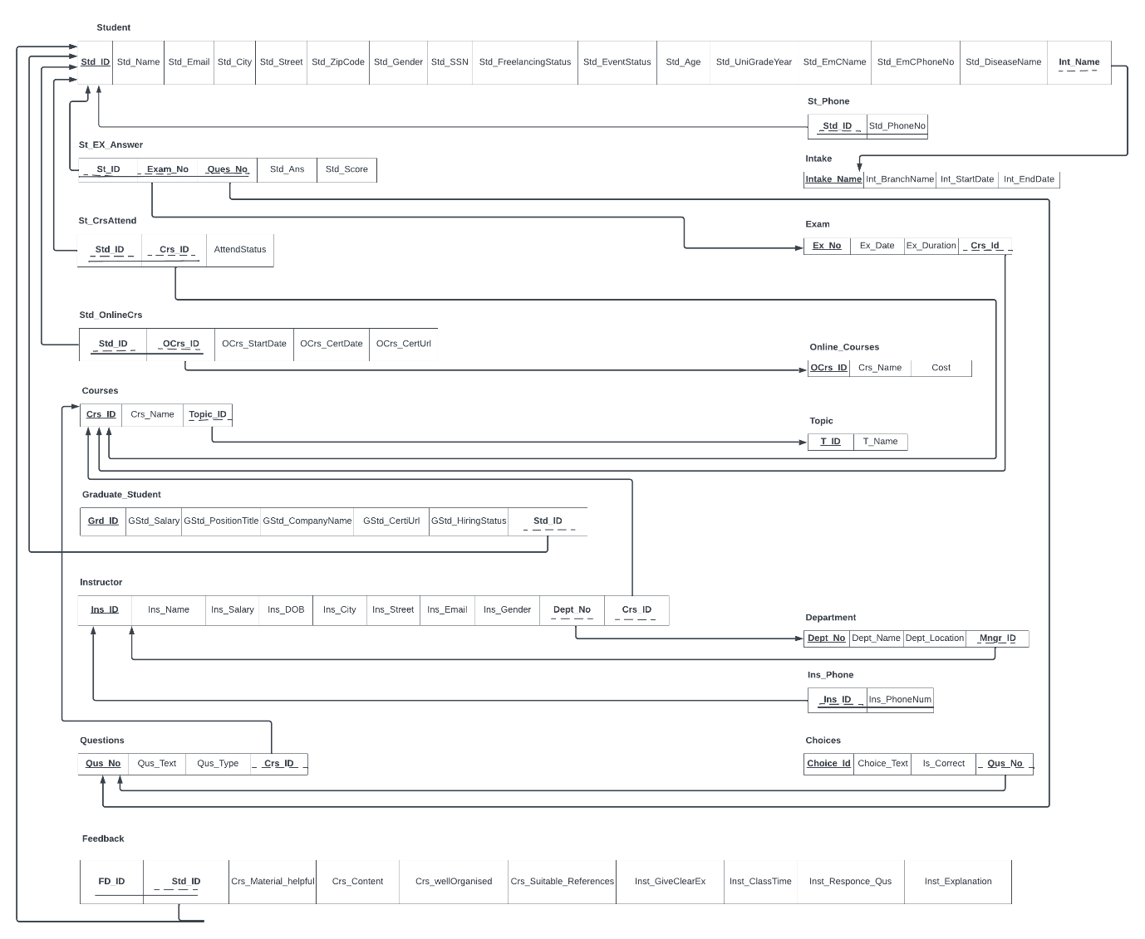

IMPLEMENTATION

Creating a database for an examination system typically involves defining tables to store information about the Topic, Course, Instructor, Student, Department, Exam, Graduate, and Feedback. Once we defined the table schema, we populated the tables with data. We used the Bulk Insert command. This command allows for the efficient insertion of large amounts of data into tables from a data file. The data file can be CSV in our system.

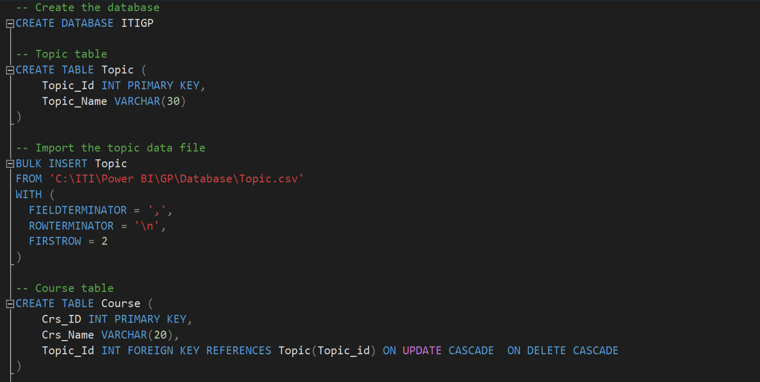

Another creation table for Std_phone with its bulk insert for getting the data from the CSV file, the stored procedure for insert, the stored procedure for select, the stored procedure for the update, and the stored procedure for delete.

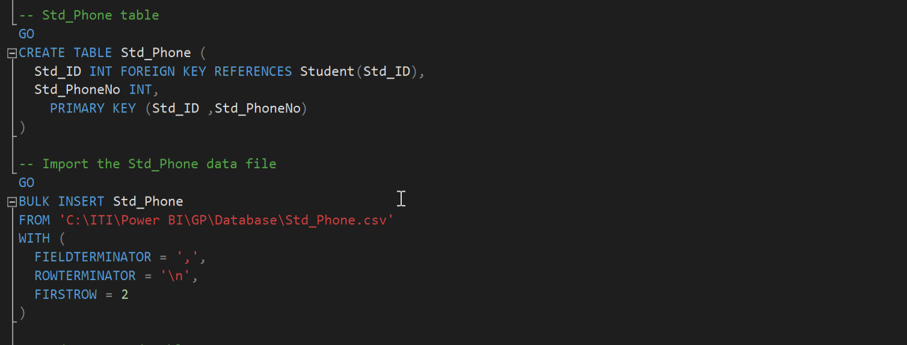

Insert Stored Procedure: insert new records into the instructor table. It can take input parameters such as the @std_ID, @std_SSN, @std_Name, and @std_city parameters.

Update Stored Procedure: update existing records in the instructor table. It can take input parameters @std_ID, @std_SSN, @std_Name, @std_city.

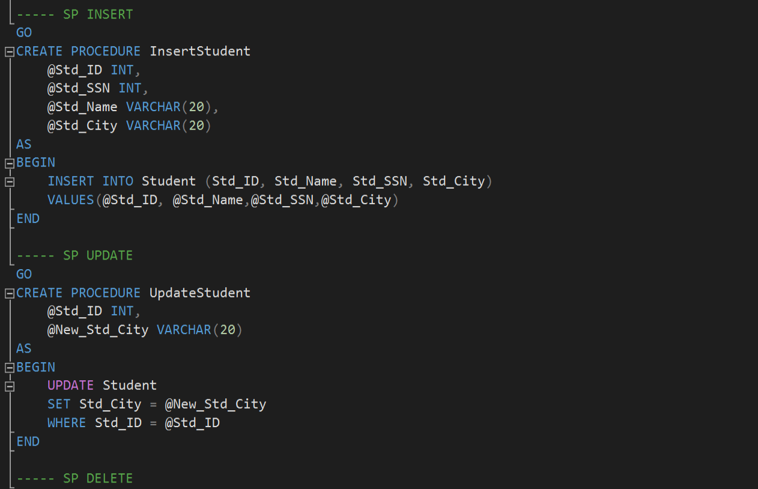

Delete Stored Procedure: delete student id records from the instructor table parameter @std_ID.

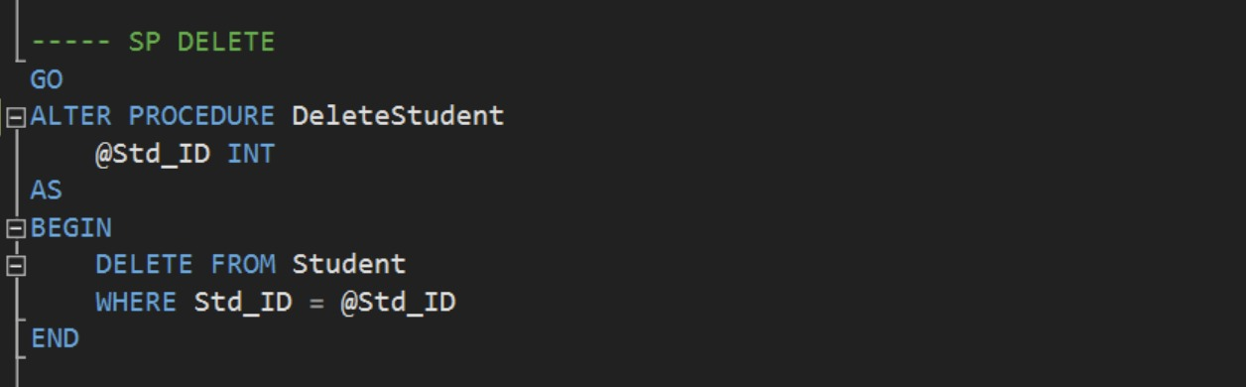

Exam generation is a stored procedure created to get the student id with the exam number if the student id is not exist print an error message, @EX_No, @Crs_ID, @Ex_Duration, @Num_IF_Questions, @Num_MCQ_Questions parameters.

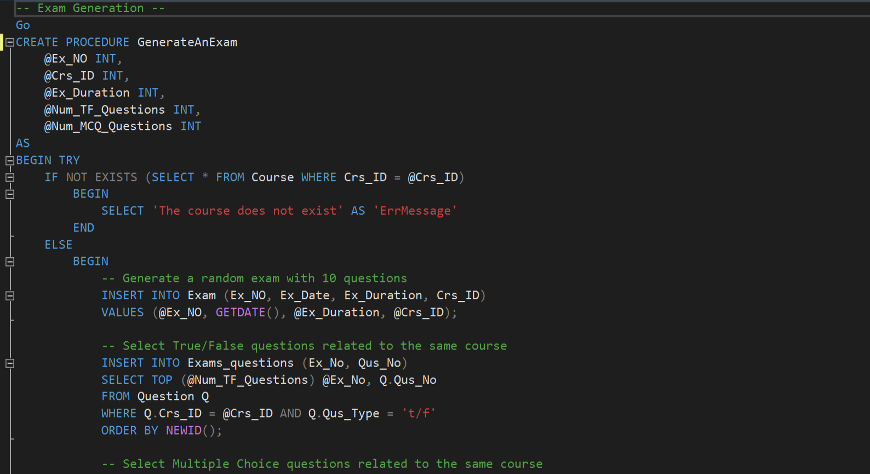

Exam answers is a stored procedure created to get the exam number with the student id, questions, and question answers if the student id does not exist or questions or the student id does not exist print an error message with the @EX_No, @Std_ID, @Qus_No, @Std_Ans parameters.

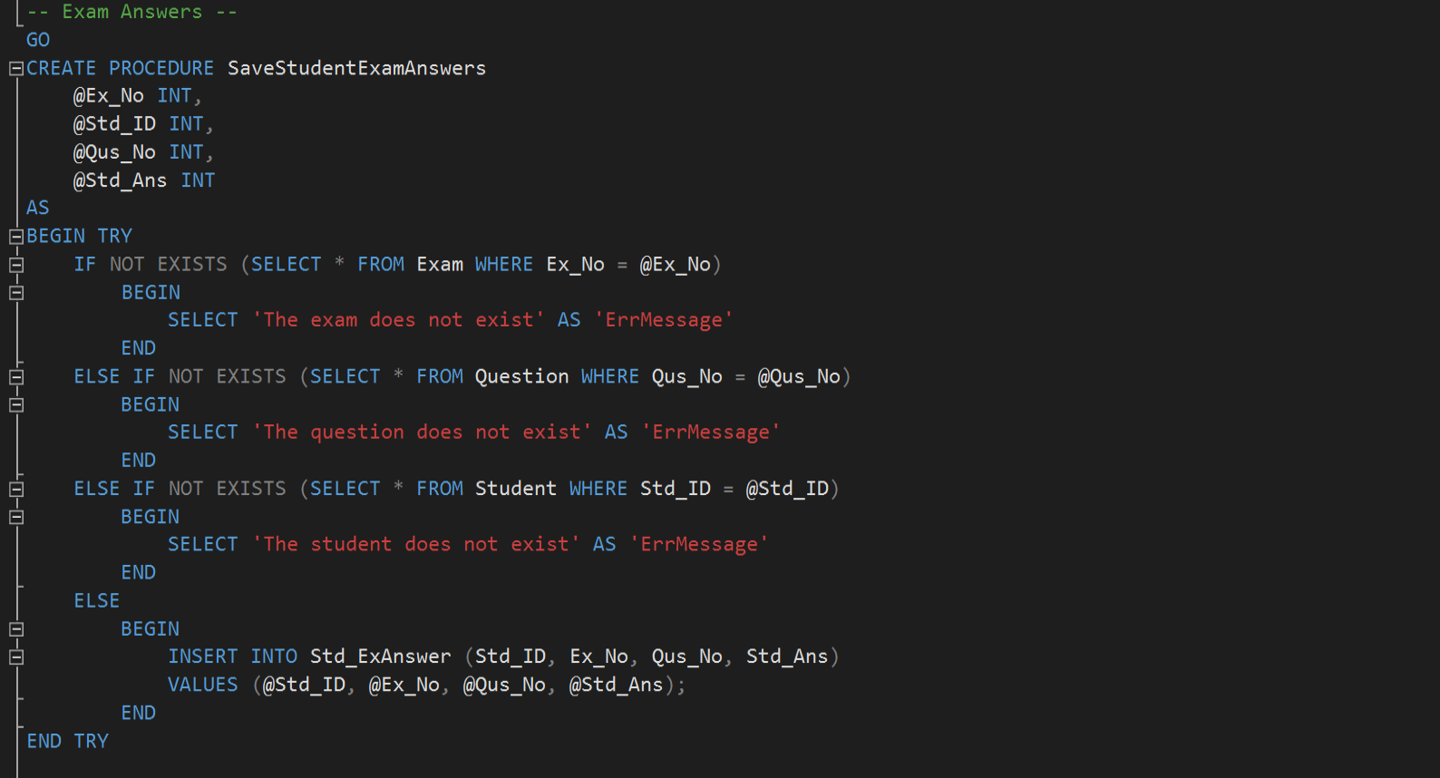

@StudentModelAnswer is a stored procedure created to get the student id with the exam number, if the student id is not exist print an error message, and get the exam number, if the exam number is not exist print an error message.

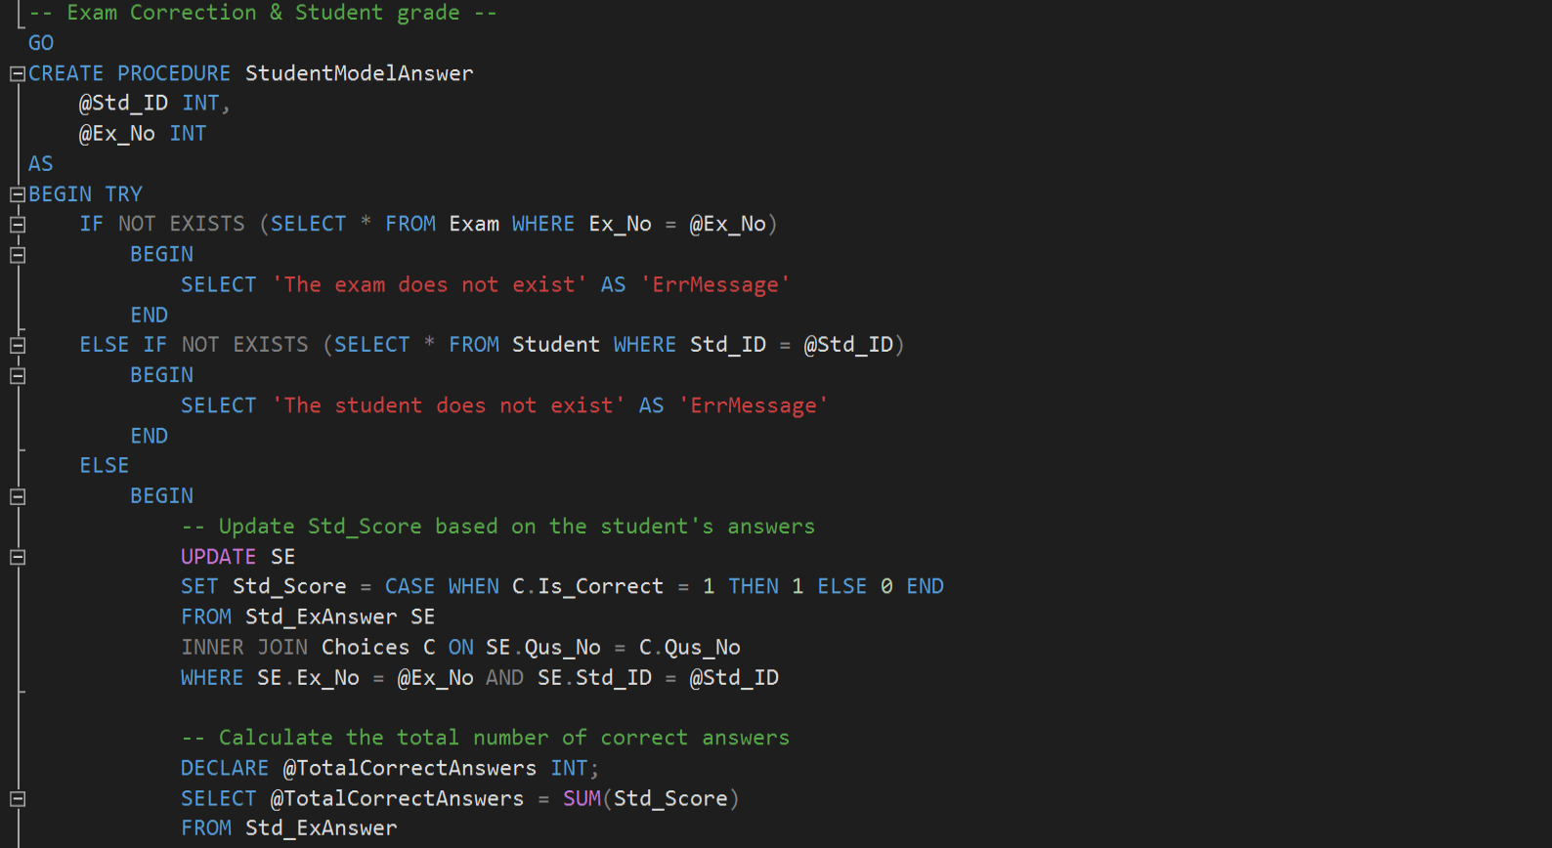

After we got the students’ ids, and exam numbers, here we could calculate the correct answers and graduate percentage by creating a stored procedure take @TotalCorrectAnswers, @TotalCorrectAnswers

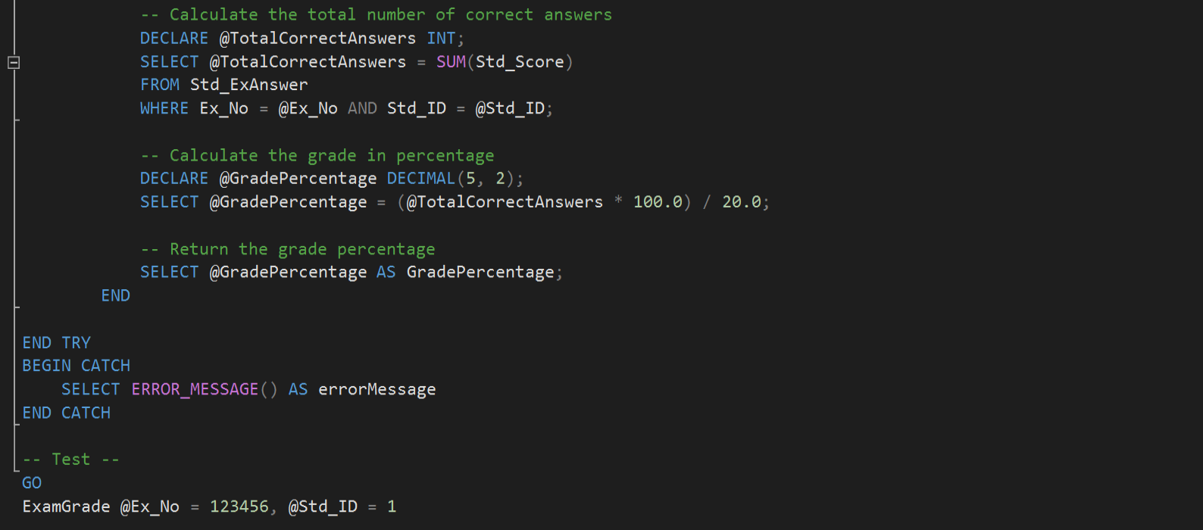

## Overview Dashboard

Analyze the examination system as a whole and explain the numbers of students, instructors, departments, etc.

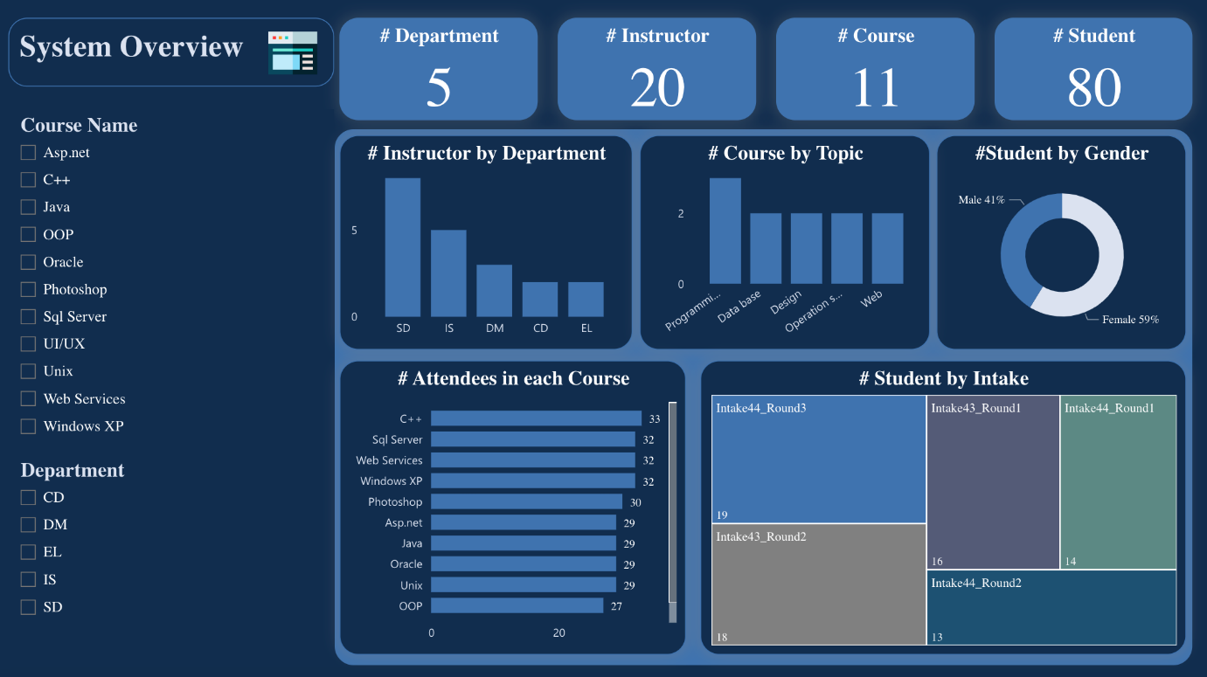

Student Enrollment Dashboard

Displays the number of students enrolled in different courses and topics.

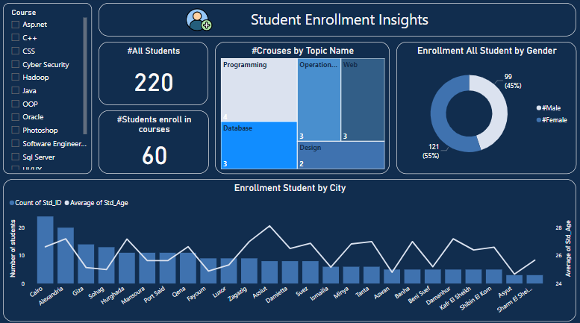

Student Attendance Dashboard

Tracks student attendance and presents attendance Status.

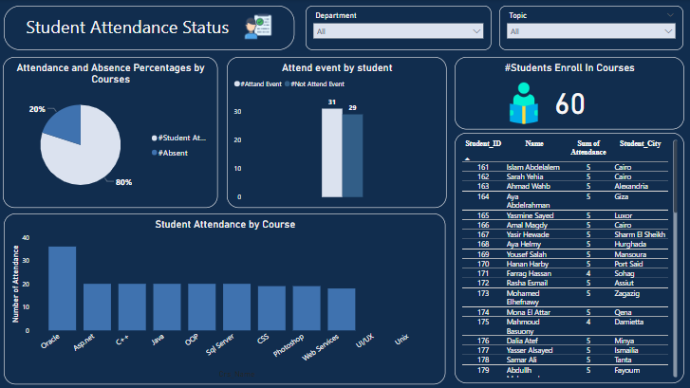

Topic Overview Dashboard

Displays the number of topics and names of courses to determine the top courses by the student's grades.

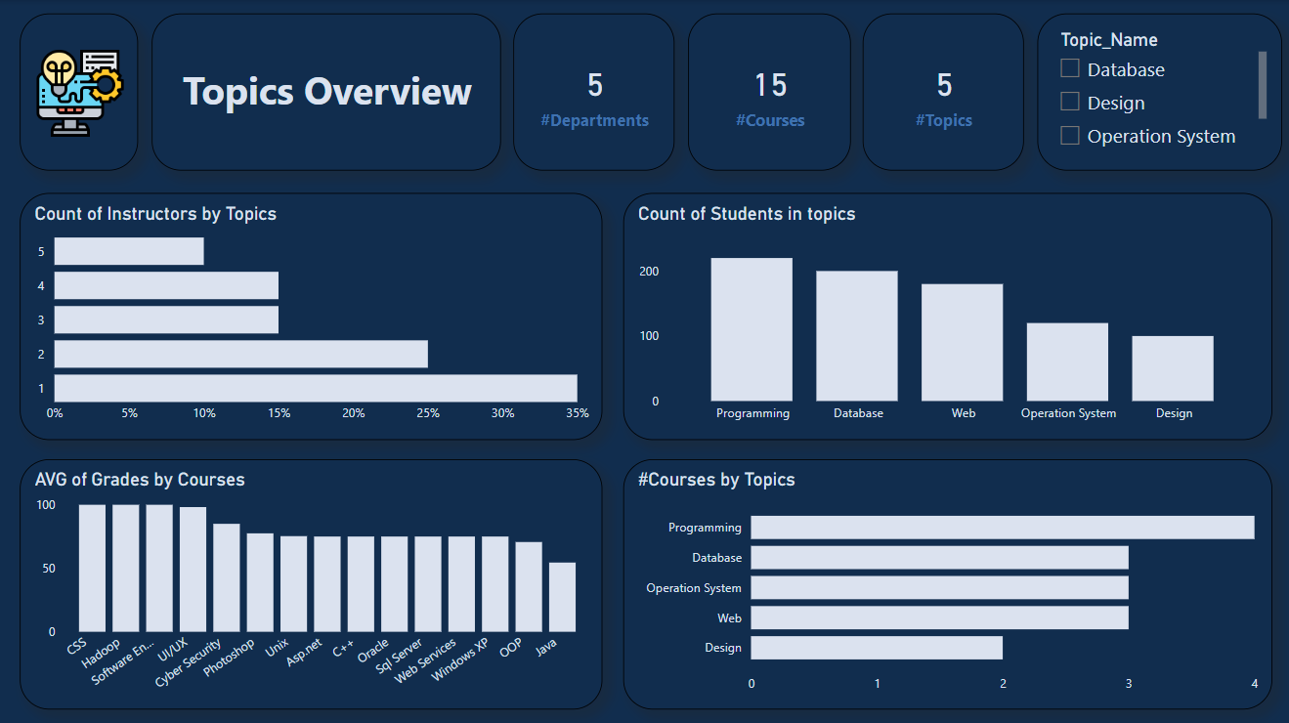

Graduate Engagement Dashboard

Measures the engagement level of alumni, such as participation in events, and the number of those hired, most companies include graduates and top 3 position titles.

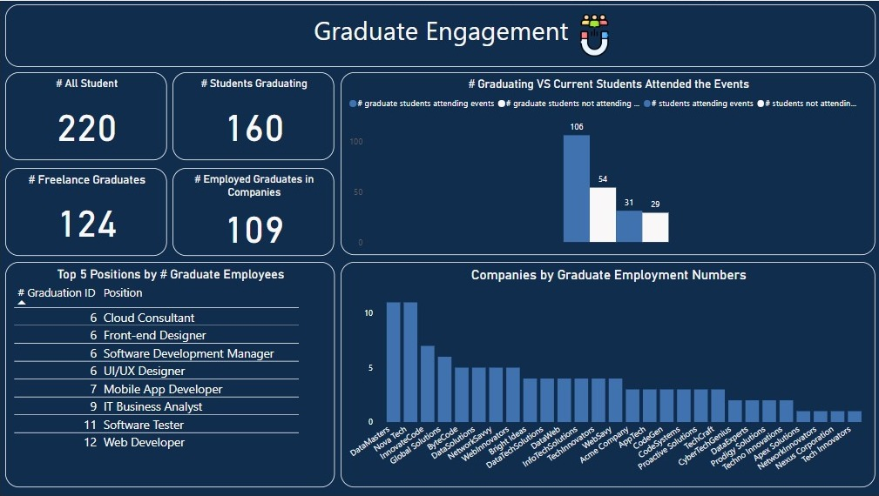

Student Demographics Dashboard

Presents demographic information about the student population, such as age, gender, and city.

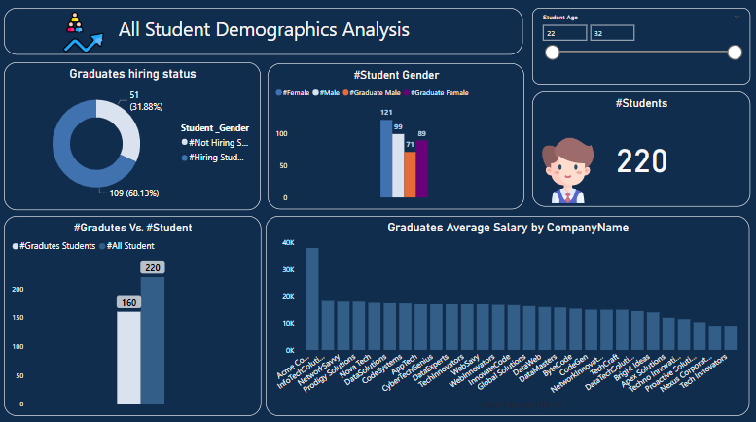

Online Course Enrollment Trends Dashboard

Displays the popularity of different courses and programs over time.



Online Learning Dashboard

Displays the number of students who completed online courses and the names of these courses.

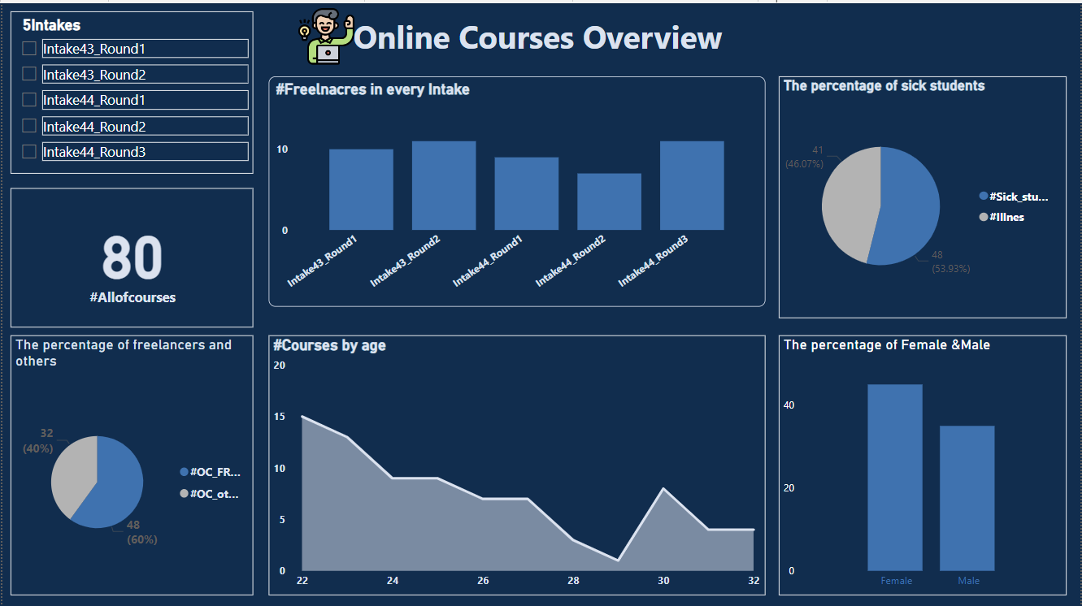

Graduate Satisfaction Dashboard

Collects and analyzes graduate satisfaction surveys to identify areas of improvement.

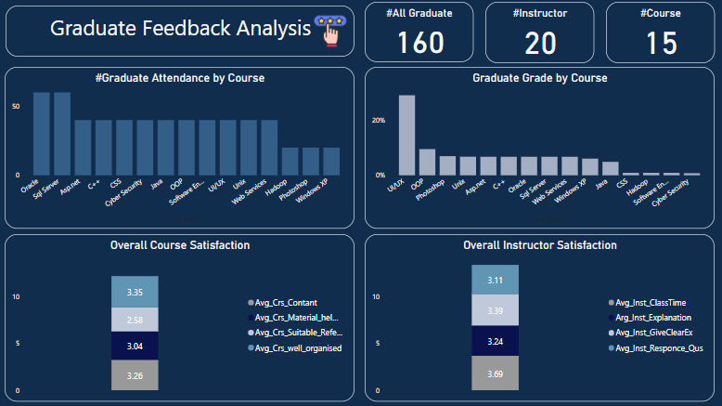

Overview Demographics Dashboard

Evaluate the institute's diversity and inclusion efforts, including student and instructor demographics.



Course Performance Dashboard

Displays the performance of different courses based on metrics like average grades and top 3 courses by student's grade.

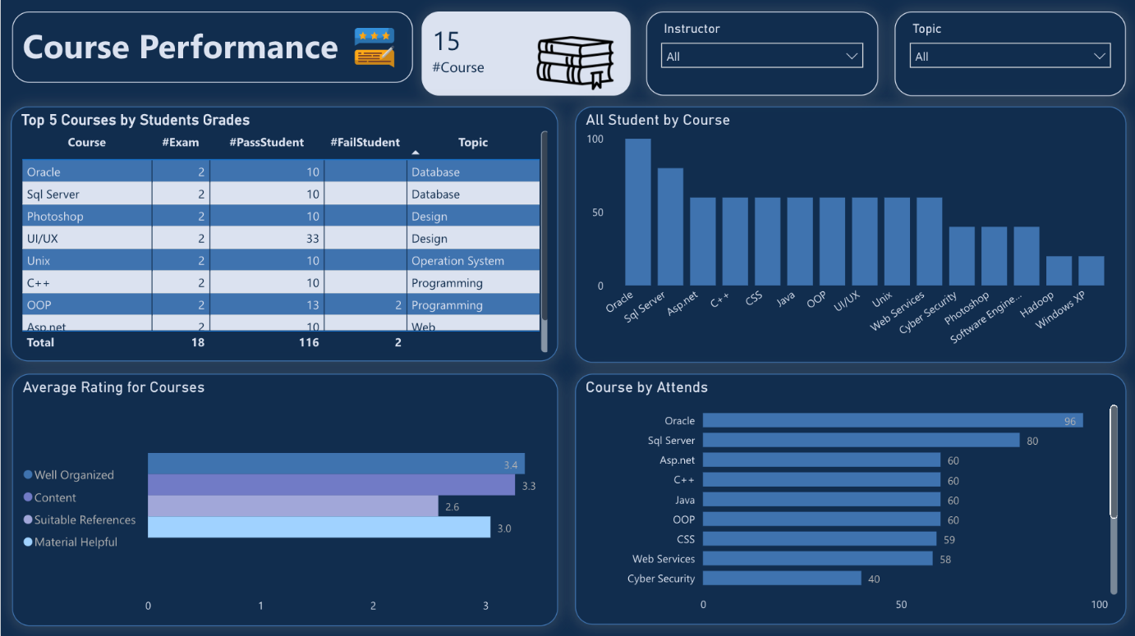

Graduate Student Progress Dashboard

Tracks the progress of individual graduates over time according to course attendance and grades.

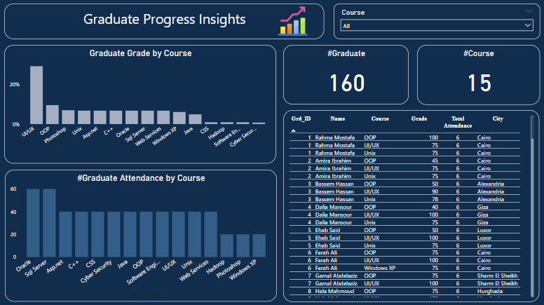

Students Freelancing Dashboard

Tracks the number of students who complete freelancing jobs.

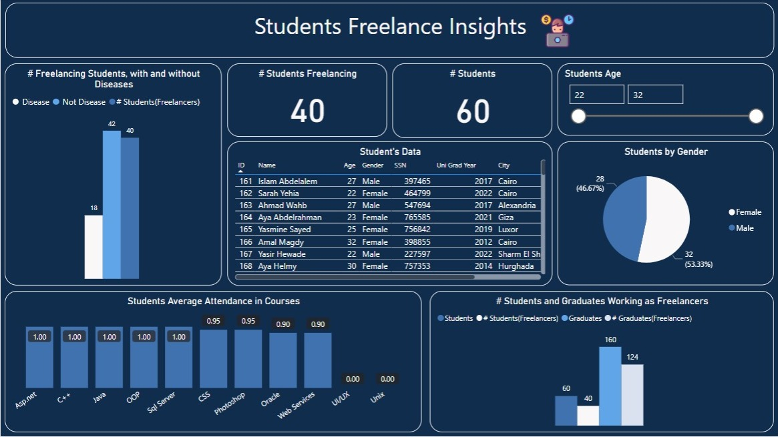

Student Health Status Dashboard

Displays the student’s health situation and its effects on the student's performance.

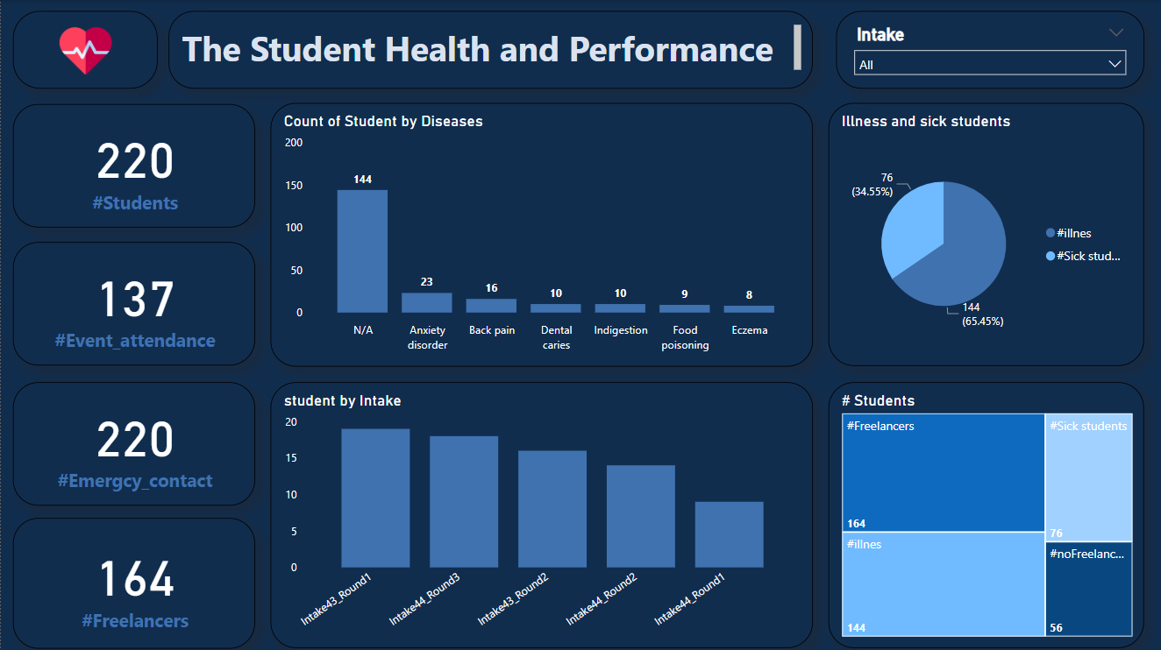

Instructors Performance Dashboard

Evaluates staff performance based on student feedback.

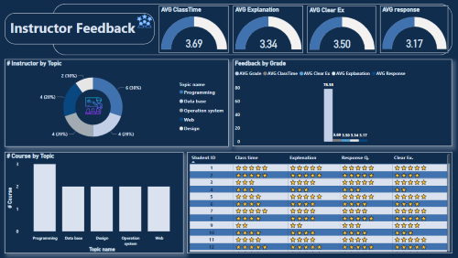

Gradebook Dashboard

Shows students' grades and performance in different exams.

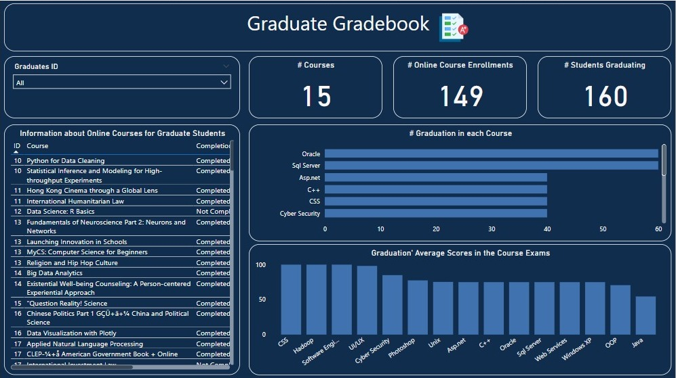

Graduation and Placement Dashboard

Tracks the number of students graduating and their employment outcomes, including job placements and career paths.

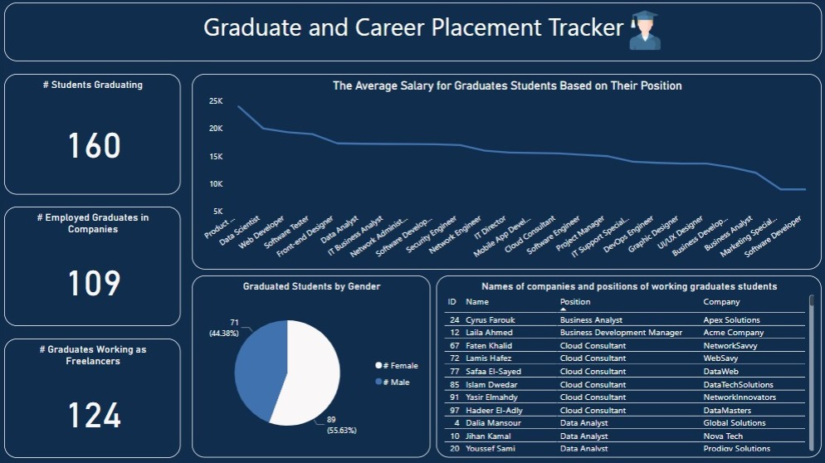

Intake Quality Dashboard

Displays feedback from students about the instructors and courses to get an idea of the intake quality.

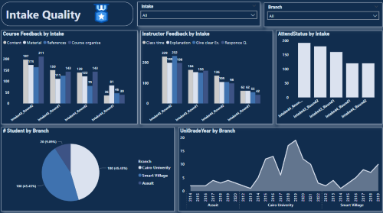

Department Overview Dashboard

Displays the number of departments, the top instructor in each one by the number of courses, and the managers of the department.

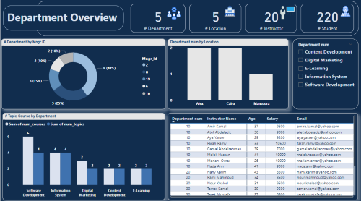

Instructor Overview Dashboard

Displays the instructor's income, most cities, and more enormous instructors by age.

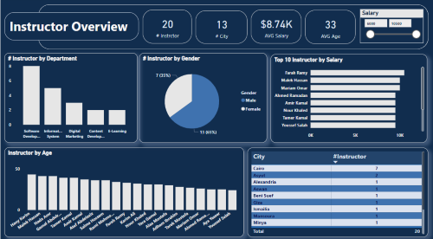

Student Social

Get some info from the student's Facebook profile, here are many samples.

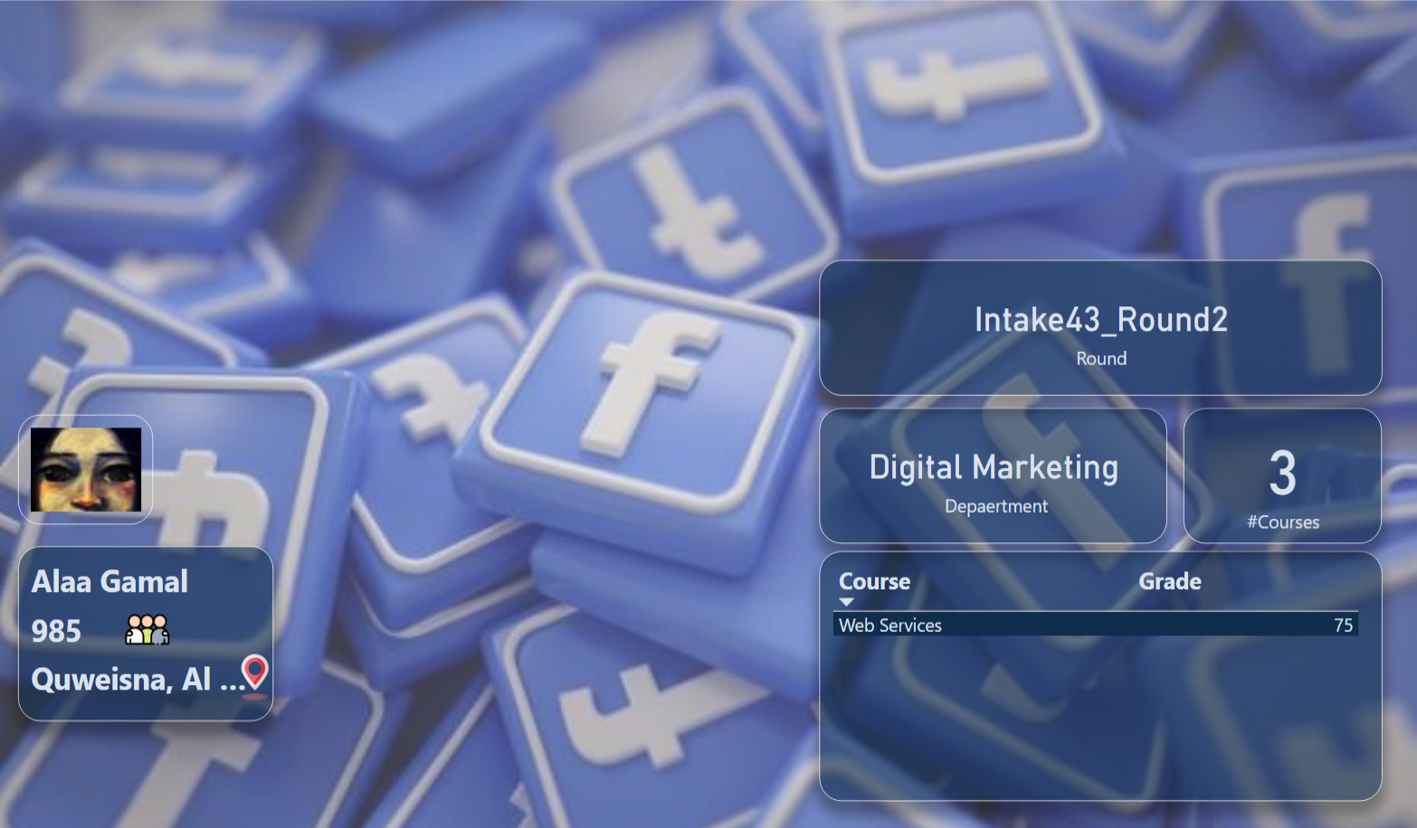

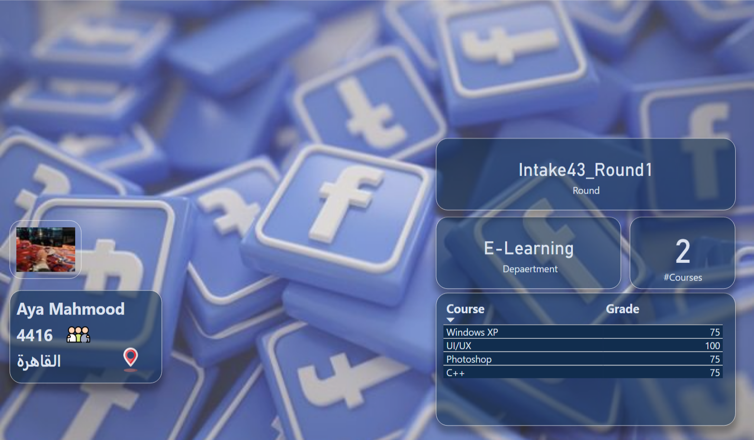

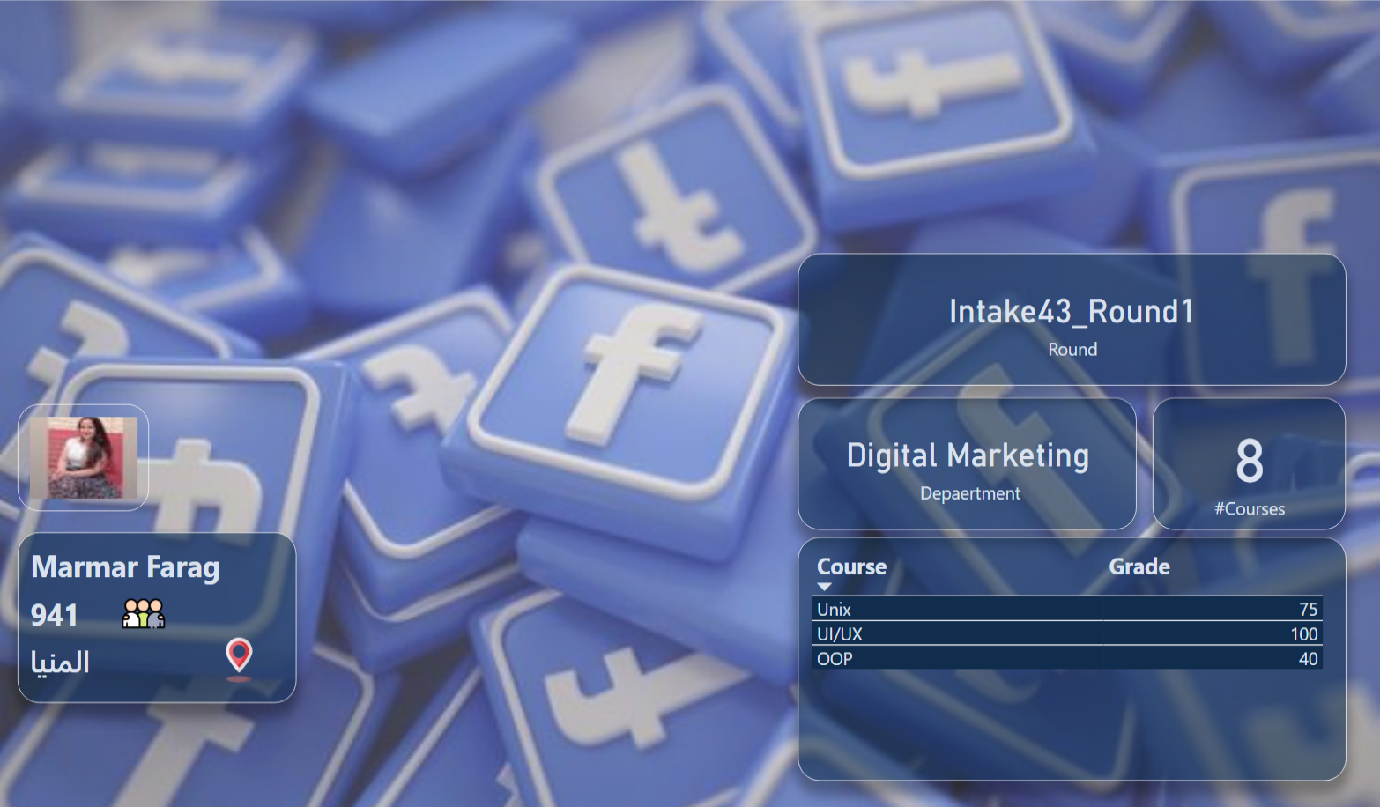

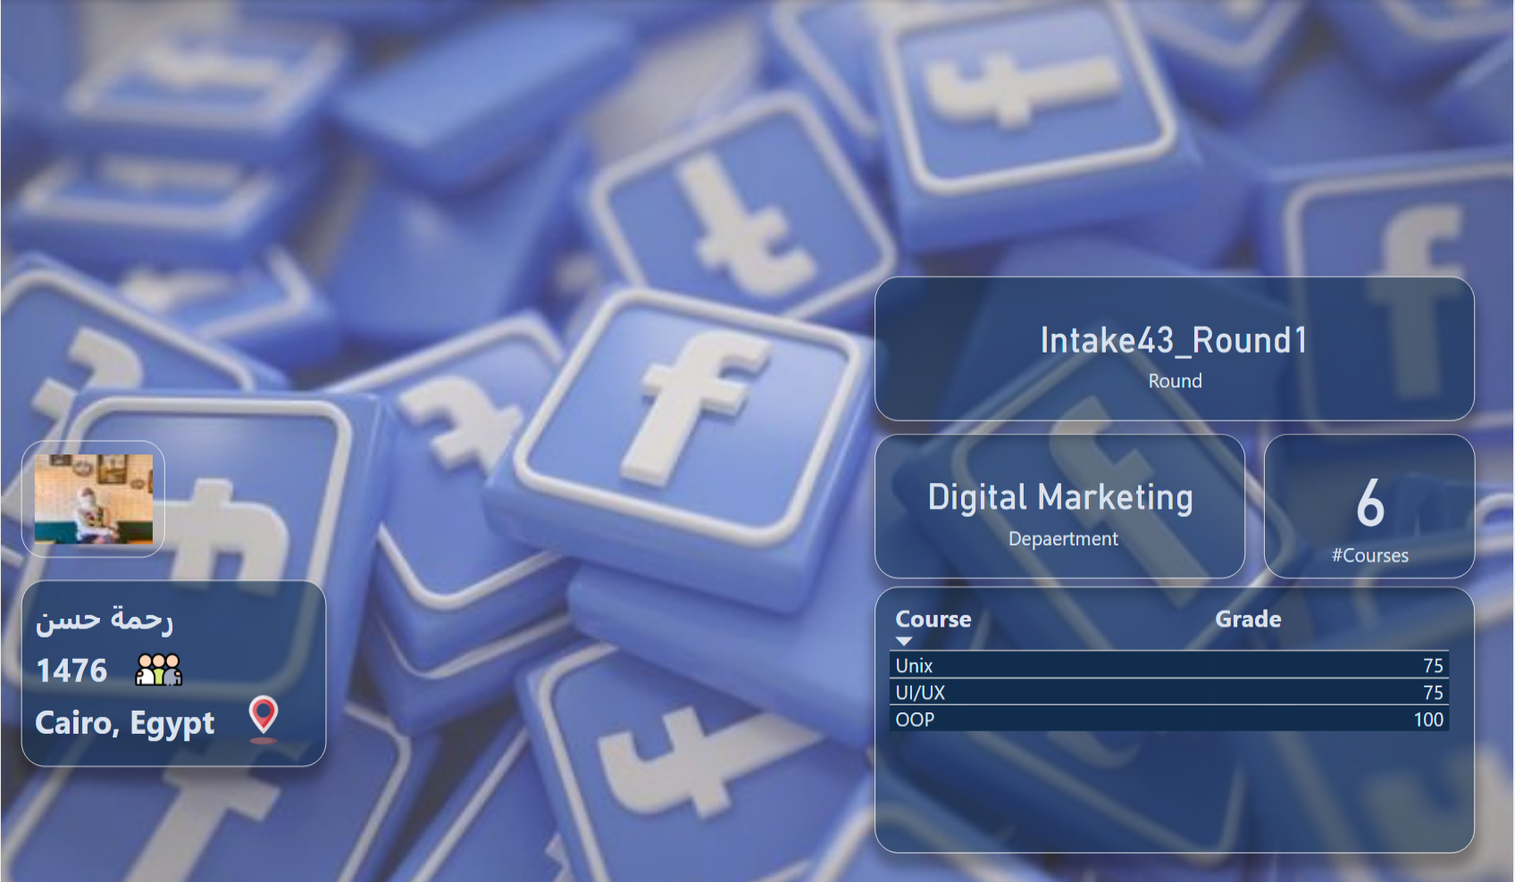

REPORTS

Instructor course summary report calling the instructor id by parameter from stored procedure made to take the instructor id and returns the department, instructor name, course, and the number of students.

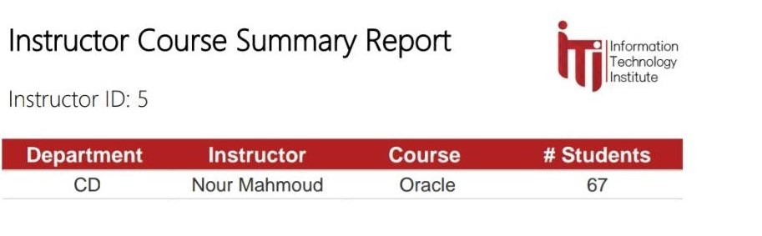

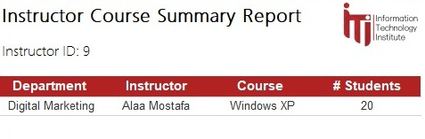

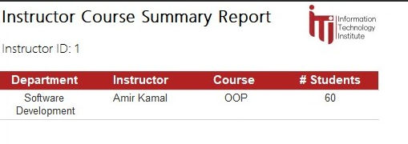

Topic by Course report calling the course id by parameter from stored procedure made to take the course id and returns the course, topic.

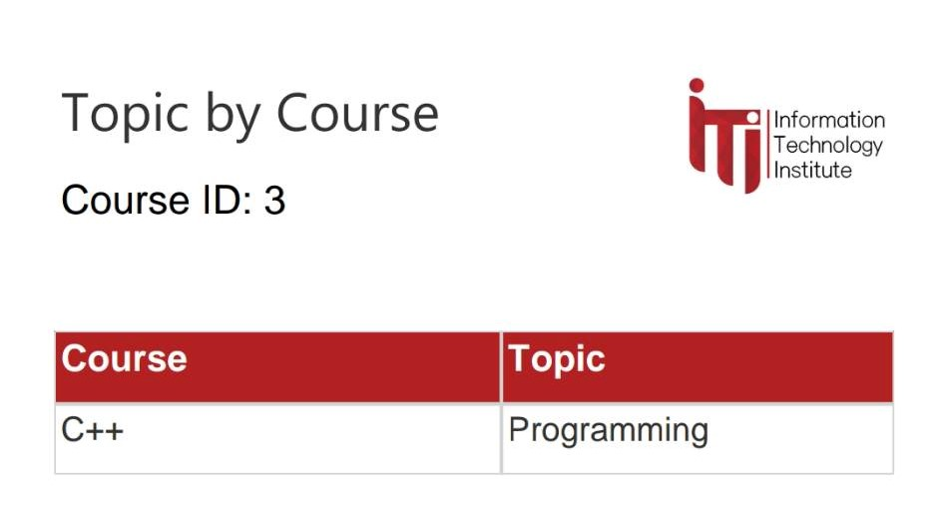

Student grades report calling the student id by parameter from stored procedure made to take the student id and return the names of the courses, and student grades.

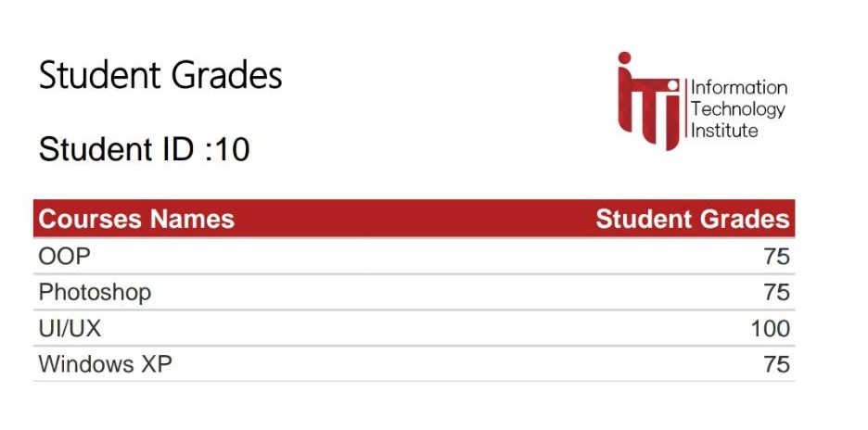

Exam report calling the exam number by parameter from stored procedure made to take the exam number and return the questions, and the answers.

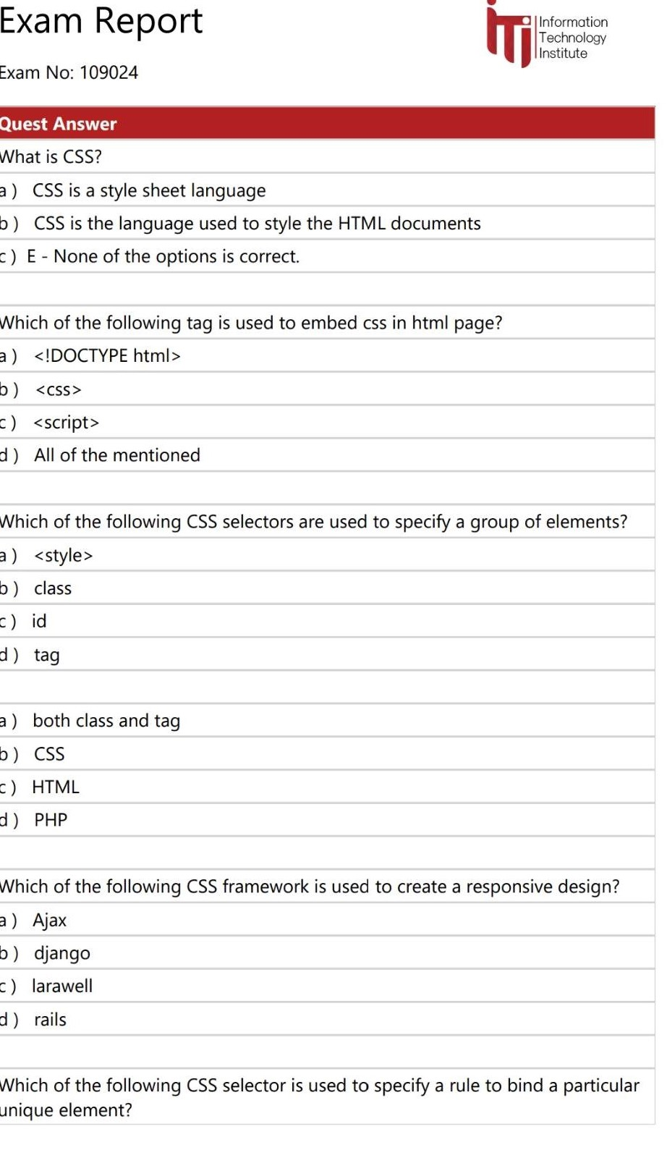

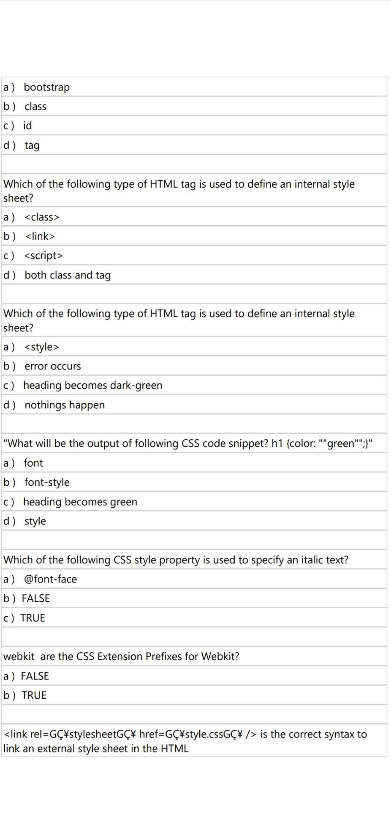

REFERENCE

### [1] WebBased online Secured Exam; B.Persis Urbana Ivy,A.shalini, A.Yamuna/International Journal of Engineering Research and Applications (IJERA) ISSN:2248-9622 www.ijera.com Vol. 2, Issue 1,JanFeb 2012, pp.943-944943.

### [2] Top-down design of entity-relationship models

C. Batini.

[3] B. Alexe, W. Tan, and Y. Velegrakis. Comparing and Evaluating Mapping Systems with STBenchmark. In *VLDB*, 2008.

[4] Rudy et al., "Implementation of Data Warehouse Data Mining and Dashboard for Higher Education", Journal of Theoretical and Applied Information Technology, pp. 710, 2014.

[5] Shweta Doshi et al., A Journey from data to dashboard: Visualizing the university Instructional classroom utilization and diversity trends with SAS Visual Analytics, pp. 8761, 2016.

[6] Ramasubramanian et al., "Reporting and Analysis Solution for efficient e-governance", SETLabs Briefings, vol. 9, no. 2, 2011.

BOOKS

[7] Database Design Using Entity-Relationship Diagrams [S Bagui](https://scholar.google.com/citations?user=Q-ui-cgAAAAJ&hl=ar&oi=sra), R Earp - 2011‏

LINKS

[8] https://www.novypro.com/project/--365-learning-data-challenge

[9] https://learn.microsoft.com/en-us/power-bi/paginated-reports/report-builder-power-bi